**Create a simple cloud software application for Flight Reservation System using any Cloud Service Provider to demonstrate SaaS include the necessary fields such as one-way, round trip, From, to, Departure, Departure, Travelers & Class, Fare Type, International and Domestic Flights etc.**

**AIM:**

To Create a simple cloud software application for Flight Reservation System using any Cloud Service

**PROCEDURE:**

**STEP 1:**

Open browser and get into zoho ceator. Then sign in and click “Create application”. Below given screenshot will appear, hear type the application name of your Aim.

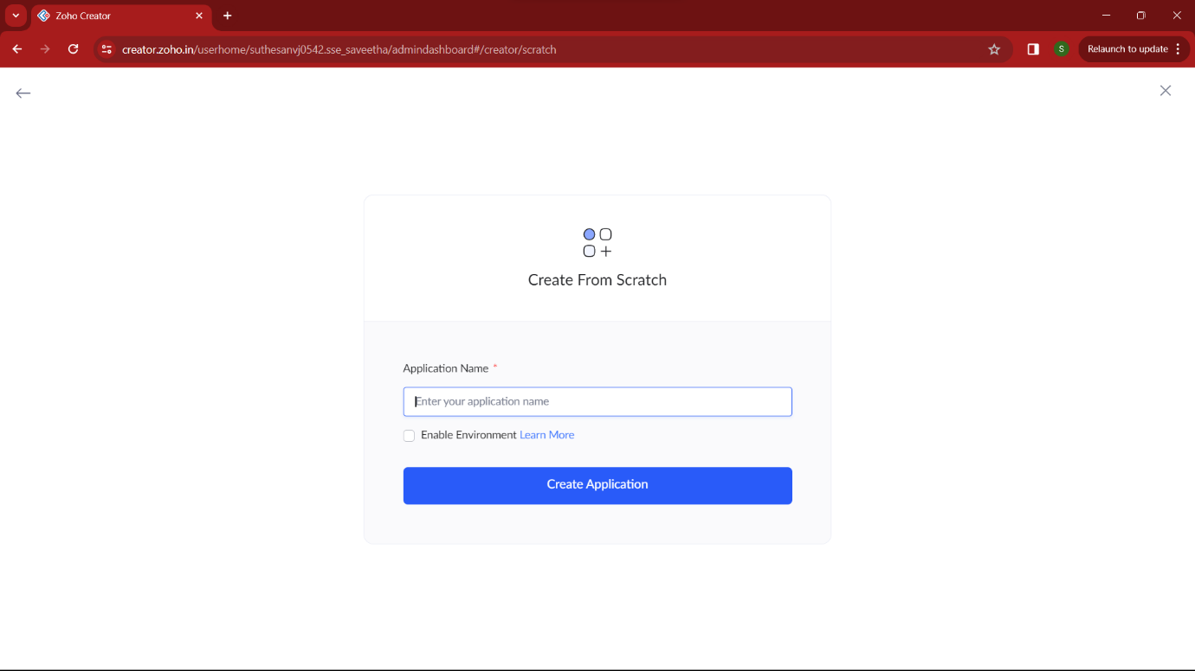

**STEP 2:**

Then select “start from scratch” option and select the proper component from the 4 components listed. For my application I just selected “forms” for the login credentials.

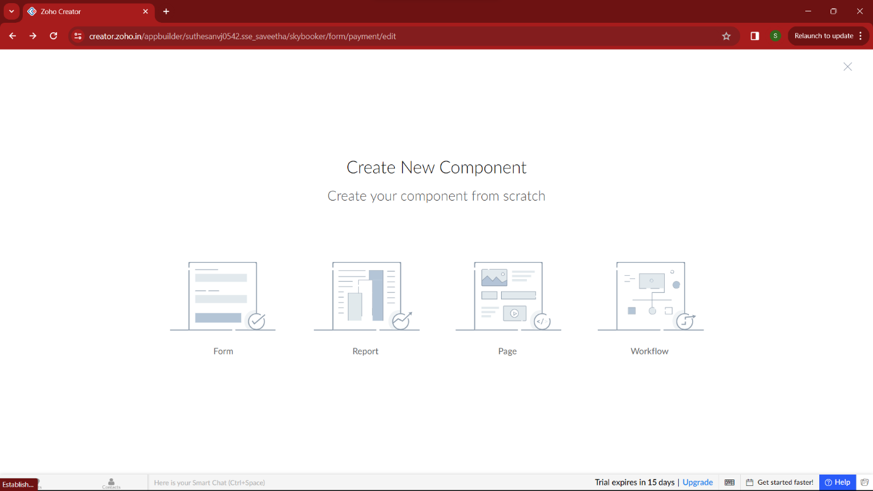

**STEP 3:**

In forms, below given options will be given. From here we can get sample templates of our requirements, otherwise we can import already saved schema for our application. I just selected “ from scratch” option for my application.

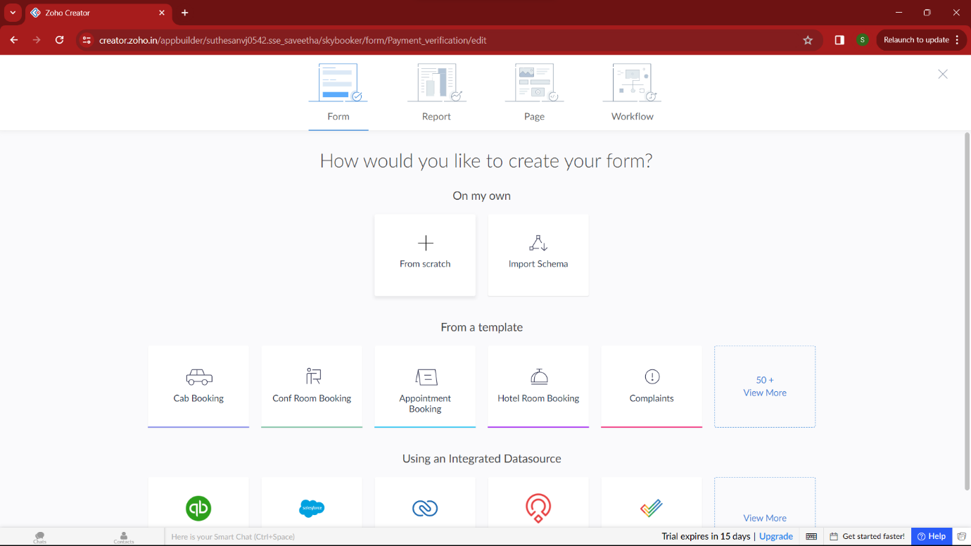

**STEP 4:**

Then provide an appropriate name for our application in the name form which shown below. I gave “SkyBooker” for my flight reservation application

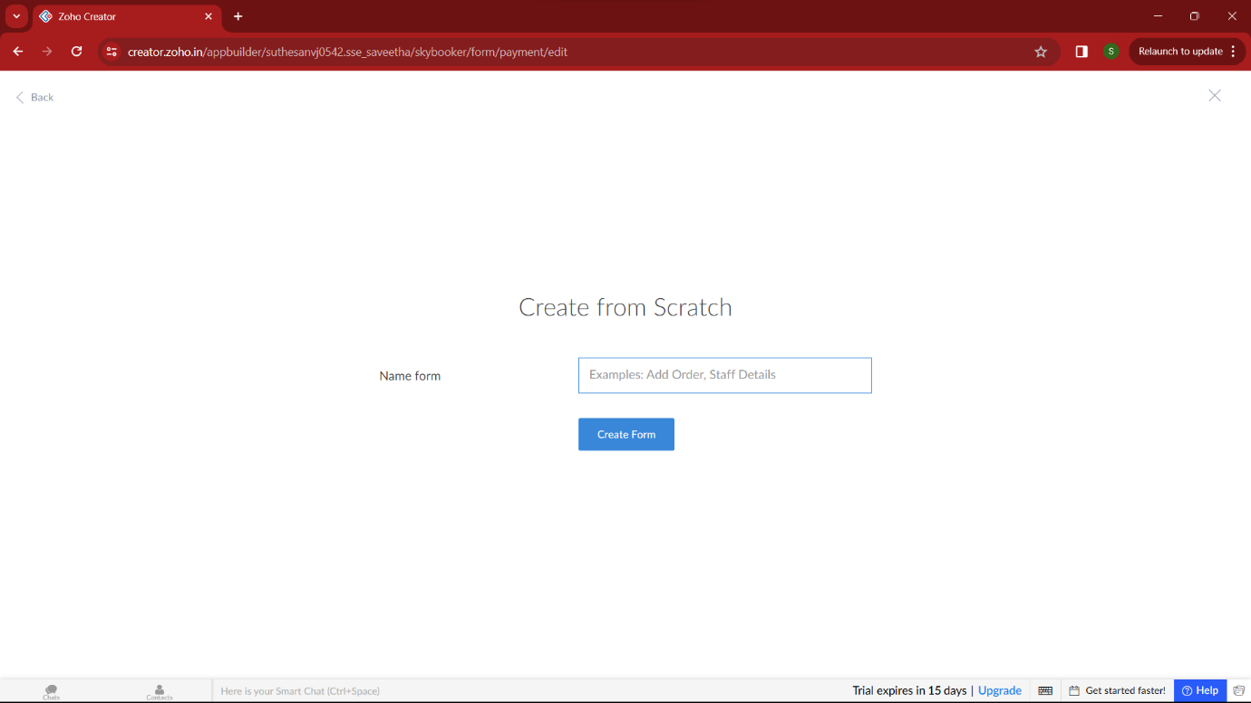

**STEP 5:**

by clicking “+” symbol shown in the picture given below, we can add number of forms in our application. Firstly I placed login form in my application with the essential credent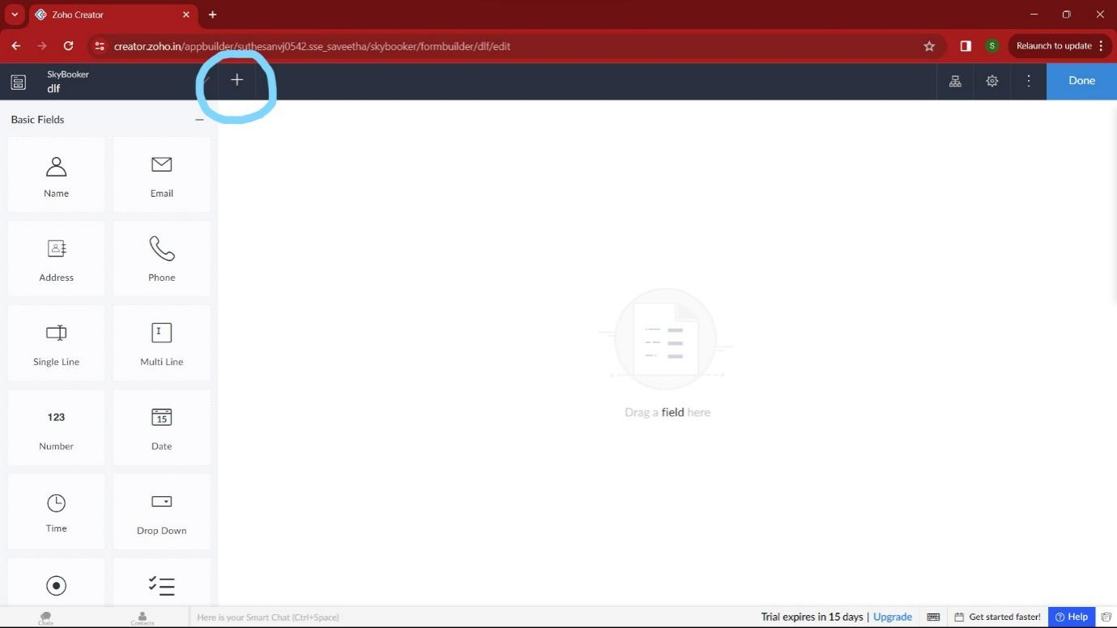

# 

**STEP 7:**

Then I added another form namely login verification. It verifies user by getting the correct OTP from user, if wrong it takes the user again to the login section/ allow to resend the OTP.

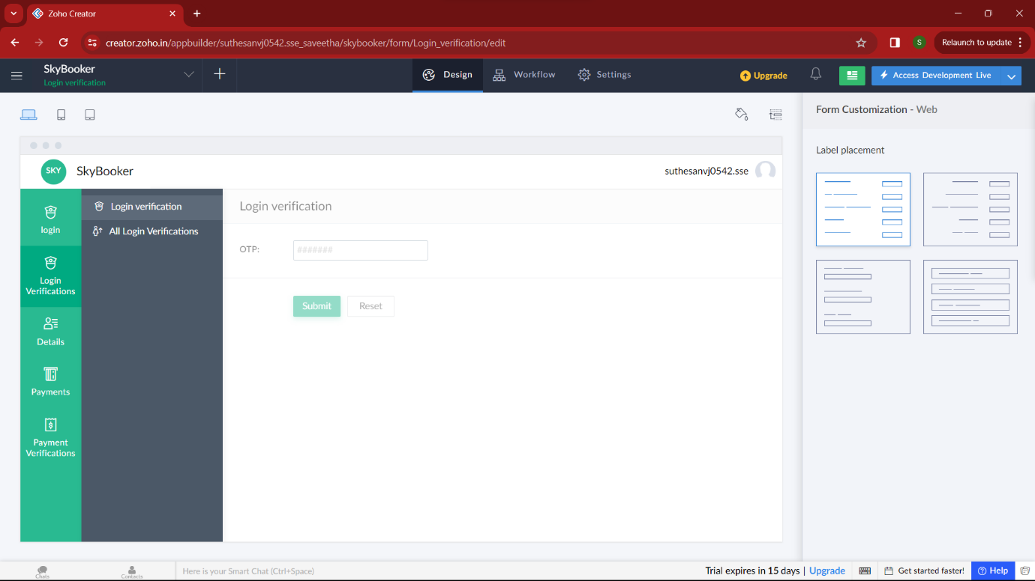

**STEP 8:**

Then I added another form namely “Travelling details” which gets all the travelling details from the user like from, to, date and time of the departure, airline, type of class, number of tickets. By these our application can find the airline by these required conditions.

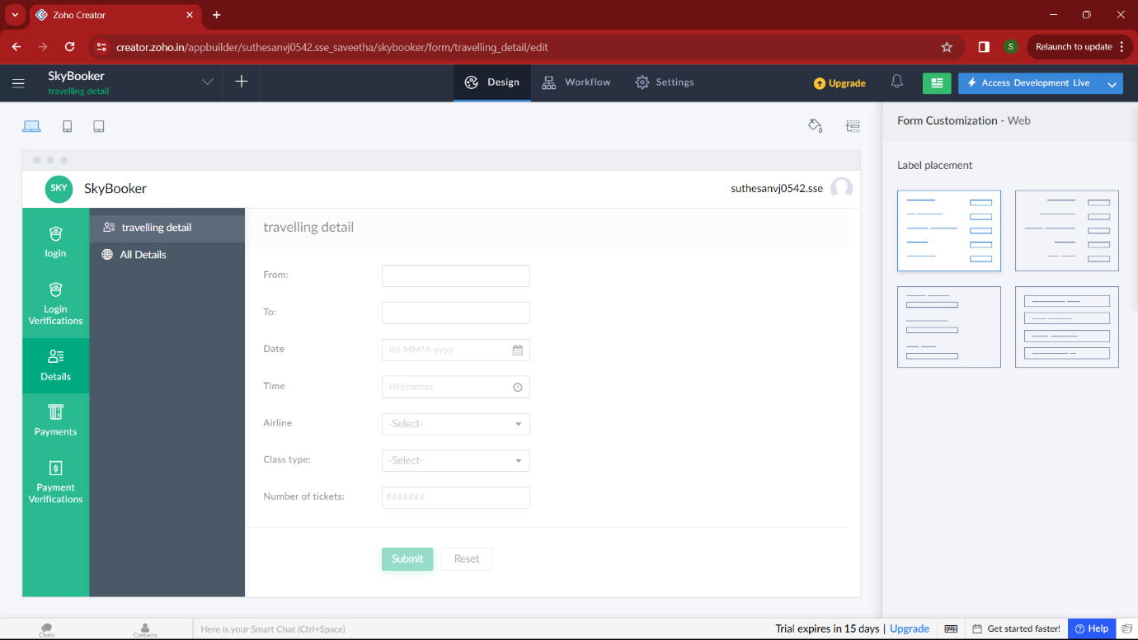

**STEP 9:**

Then n the next form I added payment methods. Here user can give the essential bank account credentials for payment and can select the mode of payment according to their convenience and pay the money.

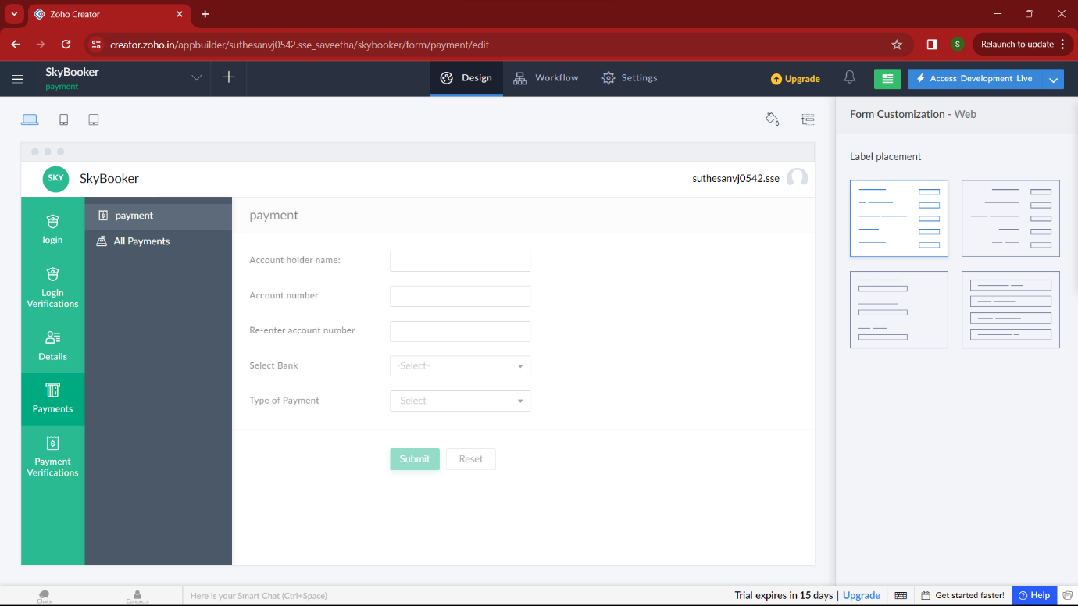

**STEP 10:**

In this form , the user will provide the correct OTP for making payment successfully, by these steps an user/customer will make the flight reservation easily.

